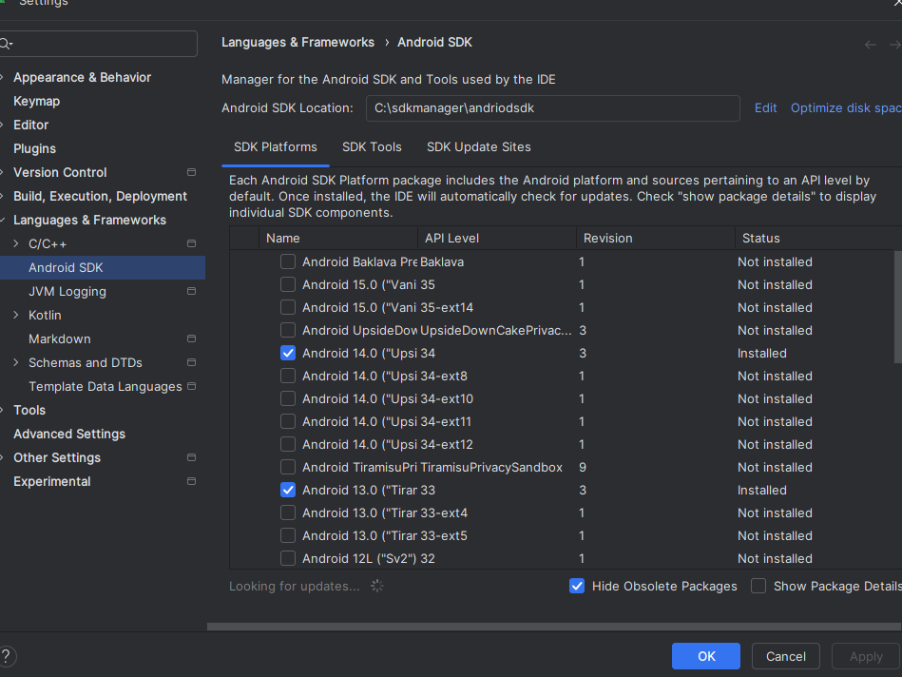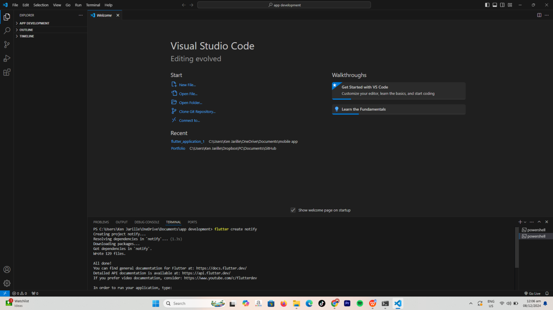The moment I installed the extentions such as flutter and dart I created a project   
  
  
  
  
  
  
  
  
  
  
  
  
  
  
  
  
  
  
  
  
  
  
  
  
I also installed the sdk files in my andriod studio

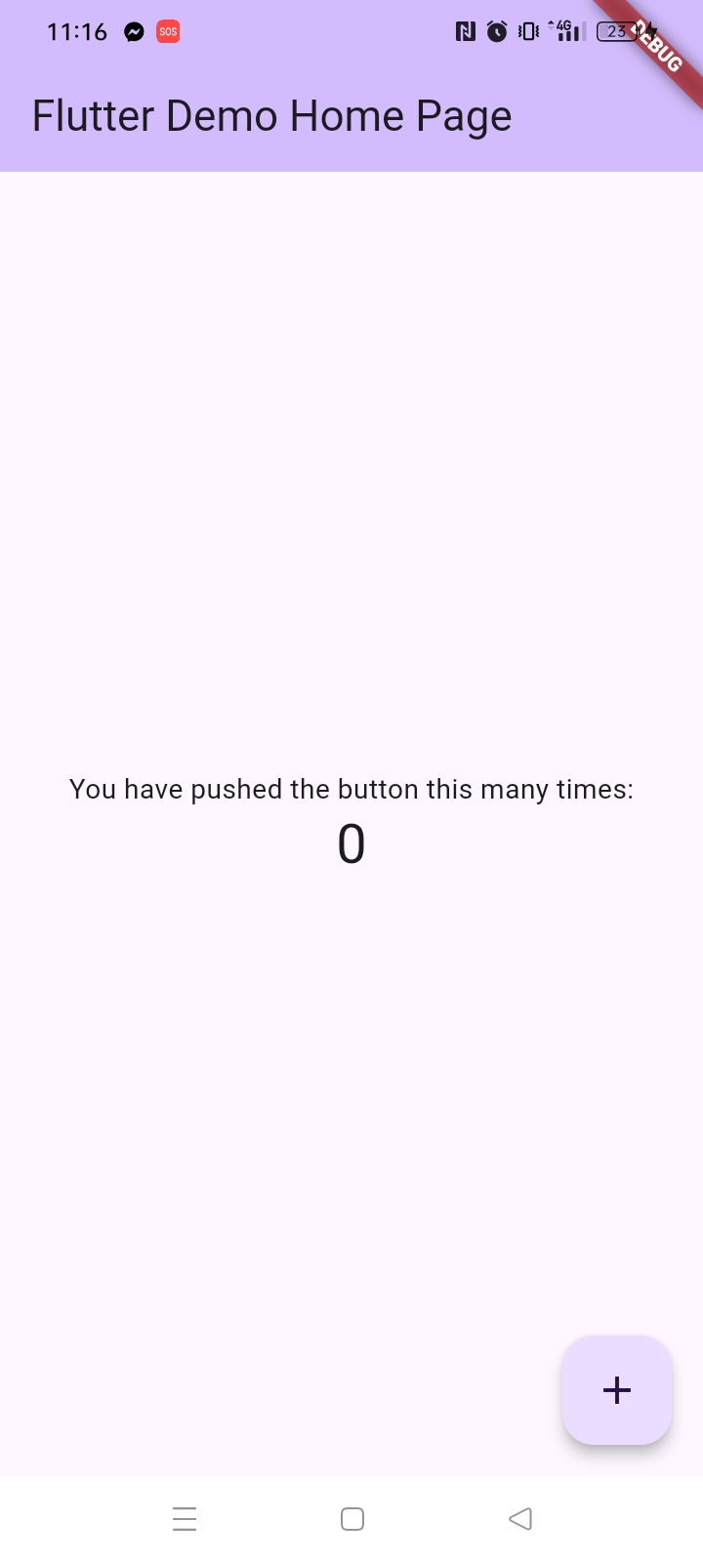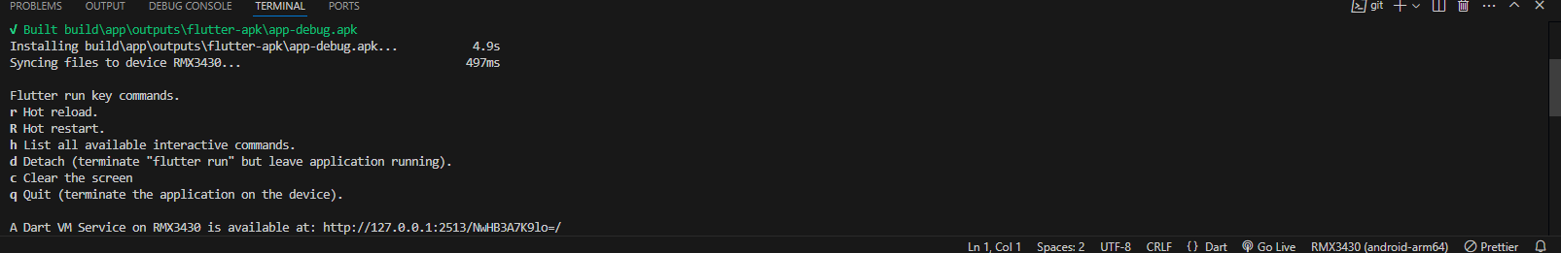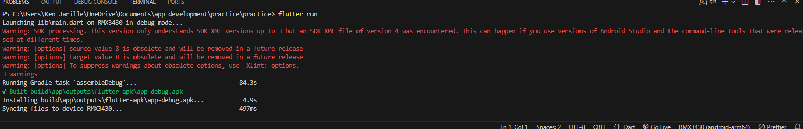And then I created a project then tried to run the app